
Pinnacle Montessori Academy of Forney
Mo( sori
.
.

Reach for the Stars
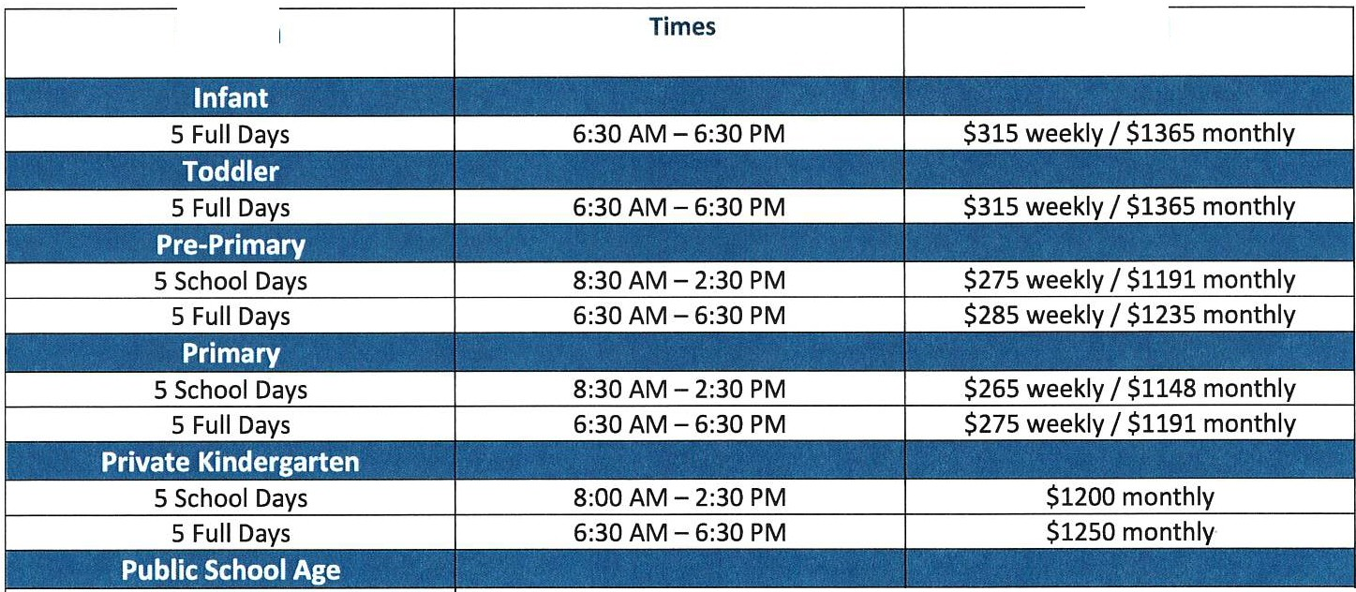
Tuition Agreement
Tuition
Tuition

Before School Only | 6:30 AM - 7:30 AM | $60 weekly/ $260 monthly
After School (includes before care) | 3:30 PM - 6:30 PM | $140 weekly/ $606 monthly
Summer Camp | 6:30 AM - 6:30 PM | $275 weekly/ $1040 monthly
Drop-In Care/Holidays | 6:30 AM - 6:30 PM | $240 weekly/ $75 per day
Extra Care/In-Service Days | 6:30 AM - 6:30 PM | $25 per day + regular tuition

 | $50 registration | $75 monthly

- Registration Fee: Non-refundable $150 paid once a year, upon registration.
- Supply Fee: $175 paid per academic semester- August, and January for (Infants - Kindergarten) $55 (public afterschool)
- Siblings Tuition Discount: 5% discount off 1"1 child's tuition rate (before/after school not included in discount); 3% off 2nd child
- Military Discount: 5% discount off the tuition rate ONLY for each child.
- Teacher Discount: 5% discount off the tuition rate ONLY for each child
- Late Pick-Up Fee: Pick-ups after 6:30 pm will be charged $10 for the first minute, and $2 per minute after 6:31pm.
- Returned payments: There will be a $50 fee for ALL returned payments/NSFs (check, credit, debit or auto-drafts)
- Late Payments: Tuition is due on Monday each week or on the 1st of each month (if paying monthly). There will be a $10 per day late fee if payment is received after these times.
- Students NOT enrolled in full day programs: Hourly Rate for early drop off (before 8:30 AM) or late pick up (after 2:30 PM) is
$10.00 per hour.
- Fee Reductions: There will be NO fee reduction for early withdrawal, holidays, family vacations, emergency closings, or teacher in-service days.
- Processing Fee: There will be a 3.5% process fee for all Credit Card Payments. There is no additional charge for Bank Draft.

Child's Name. _ Signature _ Date. _

Registration$ Tuition$ _ Discounts$
•

